HW # 1: Ansible

# Assignment:

1. Configure Ansible to deploy a webserver, and bring it up a port 80 with a web page that is publicly accessible that displays the message: “Hello World”.
2. Include in the Ansible playbook, plays to deploy and un-deploy the resources
3. Submit a Word document, showing your work via Canvas, and all code/scripts via github

# Team: Orange

1. Team Members

|  |  |
| --- | --- |
| Name | SJSU ID |
| Pranav Lodha | 00946121 |
| Jahnavi Rangu |  |
| Sheetal Narvekar |  |

1. Team Github Repository

Assignment 1: <https://github.com/plodha/CMPE-272-Assignments/tree/master/Assignment%201>

Webpage: <http://ec2-18-225-0-182.us-east-2.compute.amazonaws.com/>

# Assignment Steps

1. Create and configure Amazon EC2 instance

Amazon EC2 Instance: ec2-18-225-0-182.us-east-2.compute.amazonaws.com

|  |  |
| --- | --- |
| Instance Item | Instance Details |
| Instance Type | t2.micro |
| RAM | 1.0 gb |
| CPU | 1 Core |
| Key Pair | Pranav Key Pair |
| OS | Ubuntu 18.04 |

1. Download Ansible

Local VM

|  |  |
| --- | --- |
| Instance | Instance Details |
| Instance Type | N/A |
| RAM | 2 gb |
| CPU | 4 core |
| Key Pair | N/A |
| OS | Ubuntu 18.04 |
| Virtual Machine on | VM Ware Workstation |

Steps to install ansible:

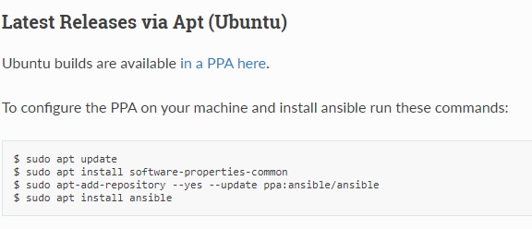

1. Configure Ansible to deploy a webserver, bring it to port 80 with a web page open.

Ansible.cfg

[defaults]

inventory = hosts

remote_user = ubuntu

private_key_file = /home/pranavlodha/.ssh/Amazon_PranavKeyPair.pem

hosts

[webserver]

ec2-18-225-0-182.us-east-2.compute.amazonaws.com

deploy_webserver.yml

- hosts: webserver

remote_user: ubuntu

become: yes

become_method: sudo

tasks:

- name: install apache2

apt: name=apache2 update_cache=yes state=latest

- name: copy index.html to server

template: src=/home/pranavlodha/Documents/index.html.j2 dest=/var/www/html/index.html

notify:

- restart apache2

handlers:

- name: restart apache2

service: name=apache2 state=restarted

index.html.j2

<html>

<body>

<h1 style="color:orange;">Hello World!</h1>

<h3>This is a hello world ansible project.</h3>

</body>

</html>

1. Configure Ansible to un-deploy the webserver

Un-deploy_webserver.yml

- hosts: webserver

remote_user: ubuntu

become: yes

become_method: sudo

tasks:

- name: uninstall apache2

apt: name=apache2 state=absent

- name: delete index.html

file:

path: /var/www/html/index.html

state: absent

# Answer

Please view the webpage at: <http://ec2-18-225-0-182.us-east-2.compute.amazonaws.com/>